**A Project Report for Web Technologies(22CS407PC)On**

**Online Student Result System**

**Submittedto**

**CMR Technical Campus,Hyderabad**

**In Partial fulfillment for the requirement of the Award of the Degree of**

**BACHELOR OF TECHNOLOGY**

**in**

**COMPUTER SCIENCE & ENGINEERING**

**By**

**SHIVA KUMAR(227R1A05J3)**

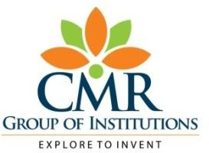 **Under the guidance of**

**Nazeema Afrin**

**DEPARTMENT OF COMPUTER SCIENCE&ENGINEERING**

**CMR TECHNICAL CAMPUS**

***An UGC Autonomous Institute***

**Accredited By NBA&NAAC with A Grade(ApprovedbyAICTE,**

**JNTU,Hyderabad) Affiliated**

**Kandlakoya(V), Medchal(M),Hyderabad-501401**

**(2023-2024)**

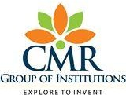

**CERTIFICATE**

This to certify that, the Presentation entitled**“Online Student Result System”**is submitted by **SHIVA KUMAR** bearing the Roll Numbers **227R1A05J3** of **B.Tech Computer Science and Engineering**. In Partial fulfillment for the requirement of the Presentation and for the award of the **Degree of Bachelor of Technology** during the academic year 2023-24.

**Subject** **Faculty**

**Nazeema Afrin**

**ESTD:2009**

**CMRTECHNICALCAMPUS**

**UGC AUTONOMOUS**

**Accredited by NBA & NAAC with ‘A’ Grade Approved byAICTE,NewDelhiandJNTUHyderabad**

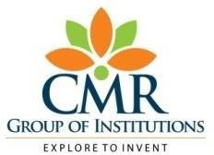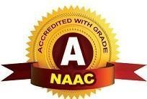**Academic Year**

**9.**

**Name of the Student**

**Roll No**

**Year**

**SemesterSection**

**Branch**

**Name of the Laboratory**

**Batch No.**

**Title of the Lab Report/Project**

**Date**

**Signature of the Student**

**:**

**:**

**:**

**:B.Tech I/II/III/IV**

**:I/II**

**:**

**:**

**:**

**:**

**:**

**:**

**:**

**:**

**Remarks/Comments by the Faculty:**

**Name of the Faculty**

**Signature of the Faculty**

**:**

**:**

|  |  |  |  |  |
| --- | --- | --- | --- | --- |
| **LABORATORYREPORT/PROJECT&PRESENTATION** | | | | |
| **Problem**  **Statement&**  **Objectives** | **Design&**  **Methodogy** | **Implementation&**  **Results** | **Total Marks** | **Final Marks** |
| **10** | **15** | **15** | **40** | **10** |
|  |  |  |  |  |

OVERVIEW

Introduction

Literature Survey

Analysis and Design

Implementation

Testing and Debugging/Results

Conclusion

Reference / Bibliography

Appendices

in College Data Management System

gives a straightforward interface to support of

understudy data, staff information,attendance,fee

record. It very well may be utilized by instructive

establishments or schools to keep up the records

of understudies without any problem. The creation

and the executives of exact, modern data with

respect to an understudies' scholastic profession is

fundamentally significant in the college just as

universities. Understudy data framework manages

all sort of understudy subtleties, scholarly related

reports, school subtleties, course subtleties,

educational program, cluster subtleties, position

subtleties and other asset related subtleties as well.

It will likewise have workforce subtleties, clump

execution subtleties, understudies' subtleties in all

perspectives, the different scholastic notices to the

staff and understudies refreshed by the school

organization. The client can updadte stuent,staff

records eliminate them effectively through the

administrator

College Data Management System

gives a straightforward interface to support of

understudy data, staff information,attendance,fee

record. It very well may be utilized by instructive

establishments or schools to keep up the records

of understudies without any problem. The creation

and the executives of exact, modern data with

respect to an understudies' scholastic profession is

fundamentally significant in the college just as

universities. Understudy data framework manages

all sort of understudy subtleties, scholarly related

reports, school subtleties, course subtleties,

educational program, cluster subtleties, position

subtleties and other asset related subtleties as well.

It will likewise have workforce subtleties, clump

execution subtleties, understudies' subtleties in all

perspectives, the different scholastic notices to the

staff and understudies refreshed by the school

organization. The client can updadte stuent,staff

records eliminate them effectively through the

administrator

College Data Management System

gives a straightforward interface to support of

understudy data, staff information,attendance,fee

record. It very well may be utilized by instructive

establishments or schools to keep up the records

of understudies without any problem. The creation

and the executives of exact, modern data with

respect to an understudies' scholastic profession is

fundamentally significant in the college just as

universities. Understudy data framework manages

all sort of understudy subtleties, scholarly related

reports, school subtleties, course subtleties,

educational program, cluster subtleties, position

subtleties and other asset related subtleties as well.

It will likewise have workforce subtleties, clump

execution subtleties, understudies' subtleties in all

perspectives, the different scholastic notices to the

staff and understudies refreshed by the school

organization. The client can updadte stuent,staff

records eliminate them effectively through the

administrator

**INTRODUCTION**

College Data Management System

gives a straightforward interface to support of

understudy data, staff information,attendance,fee

record. It very well may be utilized by instructive

establishments or schools to keep up the records

of understudies without any problem. The creation

and the executives of exact, modern data with

respect to an understudies' scholastic profession is

fundamentally significant in the college just as

universities. Understudy data framework manages

all sort of understudy subtleties, scholarly related

reports, school subtleties, course subtleties,

educational program, cluster subtleties, position

subtleties and other asset related subtleties as well.

It will likewise have workforce subtleties, clump

execution subtleties, understudies' subtleties in all

perspectives, the different scholastic notices to the

staff and understudies refreshed by the school

organization. The client can updadte stuent,staff

records eliminate them effectively through the

administrator.

College Data Management System

gives a straightforward interface to support of

understudy data, staff information,attendance,fee

record. It very well may be utilized by instructive

establishments or schools to keep up the records

of understudies without any problem. The creation

and the executives of exact, modern data with

respect to an understudies' scholastic profession is

fundamentally significant in the college just as

universities. Understudy data framework manages

all sort of understudy subtleties, scholarly related

reports, school subtleties, course subtleties,

educational program, cluster subtleties, position

subtleties and other asset related subtleties as well.

It will likewise have workforce subtleties, clump

execution subtleties, understudies' subtleties in all

perspectives, the different scholastic notices to the

staff and understudies refreshed by the school

organization. The client can updadte stuent,staff

records eliminate them effectively through the

administrator.

College Data Management System

gives a straightforward interface to support of

understudy data, staff information,attendance,fee

record. It very well may be utilized by instructive

establishments or schools to keep up the records

of understudies without any problem. The creation

and the executives of exact, modern data with

respect to an understudies' scholastic profession is

fundamentally significant in the college just as

universities. Understudy data framework manages

all sort of understudy subtleties, scholarly related

reports, school subtleties, course subtleties,

educational program, cluster subtleties, position

subtleties and other asset related subtleties as well.

It will likewise have workforce subtleties, clump

execution subtleties, understudies' subtleties in all

perspectives, the different scholastic notices to the

staff and understudies refreshed by the school

organization. The client can updadte stuent,staff

records eliminate them effectively through the

administrator.

The Online Student Result System is a comprehensive and user-friendly platform designed to streamline the management of academic records and the publication of student results. Educational institutions often face challenges in maintaining accurate and up-to-date information regarding students' academic performance, which is crucial for both colleges and universities. Traditional manual systems for managing student data, staff information, attendance, and fee records are prone to inefficiencies, errors, and delays. With the advancement of digital technology, there is an increasing demand for automated systems that can handle these processes more effectively.

This system is designed to address the specific needs of educational institutions by providing a centralized platform that manages all aspects of student information, including academic records, course details, and performance metrics. The Online Student Result System ensures the creation and management of accurate and current data related to students' academic careers, supporting the efficient operation of colleges and universities. It handles a wide range of student details, including academic reports, course details, curriculum information, and performance metrics. Additionally, it includes faculty details, batch performance metrics, and various academic notifications updated by the school administration.

The system provides a straightforward interface for the maintenance of student and staff records. Administrators can easily update, add, or remove student and staff information through a secure administrative interface. This functionality extends to managing classes and subjects, allowing for the addition, modification, and deletion of courses and subjects as needed. Furthermore, the system supports the creation, publication, and viewing of student results, enabling timely access to academic performance information for students and parents.

College Data Management System

gives a straightforward interface to support of

understudy data, staff information,attendance,fee

record. It very well may be utilized by instructive

establishments or schools to keep up the records

of understudies without any problem. The creation

and the executives of exact, modern data with

respect to an understudies' scholastic profession is

fundamentally significant in the college just as

universities. Understudy data framework manages

all sort of understudy subtleties, scholarly related

reports, school subtleties, course subtleties,

educational program, cluster subtleties, position

subtleties and other asset related subtleties as well.

It will likewise have workforce subtleties, clump

execution subtleties, understudies' subtleties in all

perspectives, the different scholastic notices to the

staff and understudies refreshed by the school

organization. The client can updadte stuent,staff

records eliminate them

**LITERATURE SURVEY**

A Online student Result system ,Educational institutions traditionally manage academic records and results manually. This manual approach involves maintaining paper-based records, manually entering student data, calculating results, and distributing report cards. Such systems are highly prone to errors, inconsistencies, and data loss. Manual processes are time-consuming and labor-intensive, requiring significant human resources to handle routine tasks, which can lead to high administrative costs. Moreover, manual systems often result in delays in the publication of results, causing frustration among students and parents.

With the rapid advancement of digital technology, there is an increasing need for automated systems that streamline administrative processes in educational institutions. Digital systems can automate data entry, calculation of results, and dissemination of information, thereby improving accuracy and efficiency. Automated systems can also provide valuable insights through data analysis, helping educators make informed decisions. Consequently, many institutions are transitioning from manual systems to digital solutions to enhance their administrative efficiency and improve the overall academic experience for students.

Several existing systems offer partial solutions to the challenges faced by educational institutions in managing academic records and results:

#### Manual Systems

Manual systems involve maintaining physical records of student information, classes, subjects, and results. These systems are inherently inefficient due to the following reasons:

* **Prone to Errors**: Manual data entry is susceptible to human errors, leading to incorrect records and calculation mistakes.
* **Delays**: The process of manually calculating results and generating report cards is time-consuming, resulting in delays in the publication of results.
* **High Administrative Costs**: Manual systems require significant human resources to manage records, enter data, and handle administrative tasks, leading to high operational costs.
* **Inaccessibility**: Physical records are not easily accessible to students and parents, especially if they are stored in different locations.

**ANALYSIS AND DESIGN**

* .

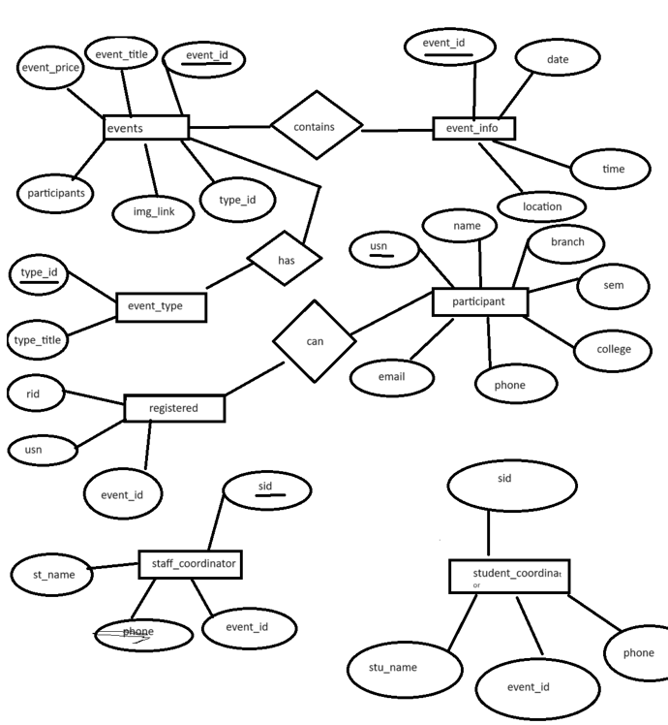

## IMPLEMENTATION

Implementing a Online Student Result System(osrs) using a Database Management System (DBMS) involves several key steps:

### Technologies Used

* **Front-End**: HTML, CSS, JavaScript
* **Back-End**: PHP, Python, or Node.js
* **Database**: MySQL or PostgreSQL
* **Frameworks**: Bootstrap for responsive design, Django or Flask for back-end logic

### Modules

1. **Admin Module**: Includes functionalities for managing classes, subjects, students, and results.
2. **Student Module**: Allows students to view their results.

### Implementation Steps

1. **Setup Environment**: Install necessary software and tools.
2. **Design Database Schema**: Create tables and relationships.
3. **Develop Front-End**: Design user interfaces for admin and student dashboards.
4. **Develop Back-End**: Implement business logic and data handling.
5. **Integrate Modules**: Ensure seamless interaction between front-end and back-end.
6. **Deploy System**: Host the application on a web server.

**Code:**

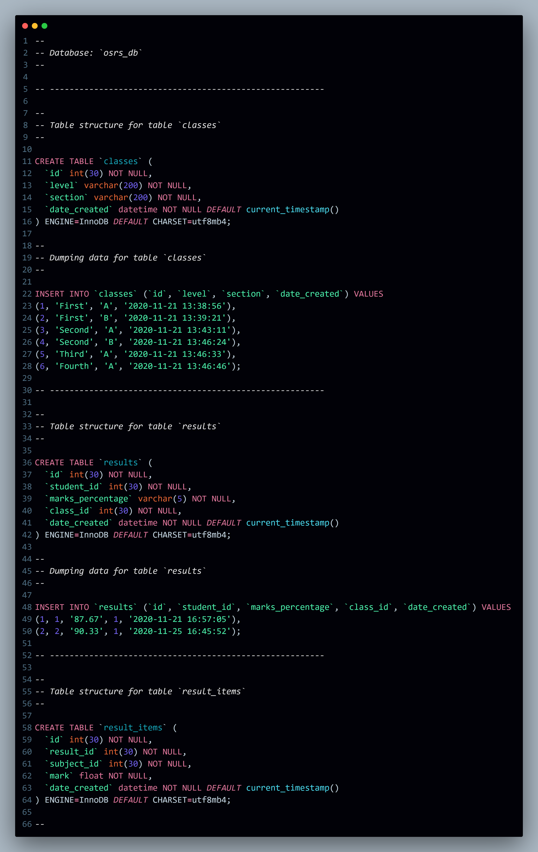

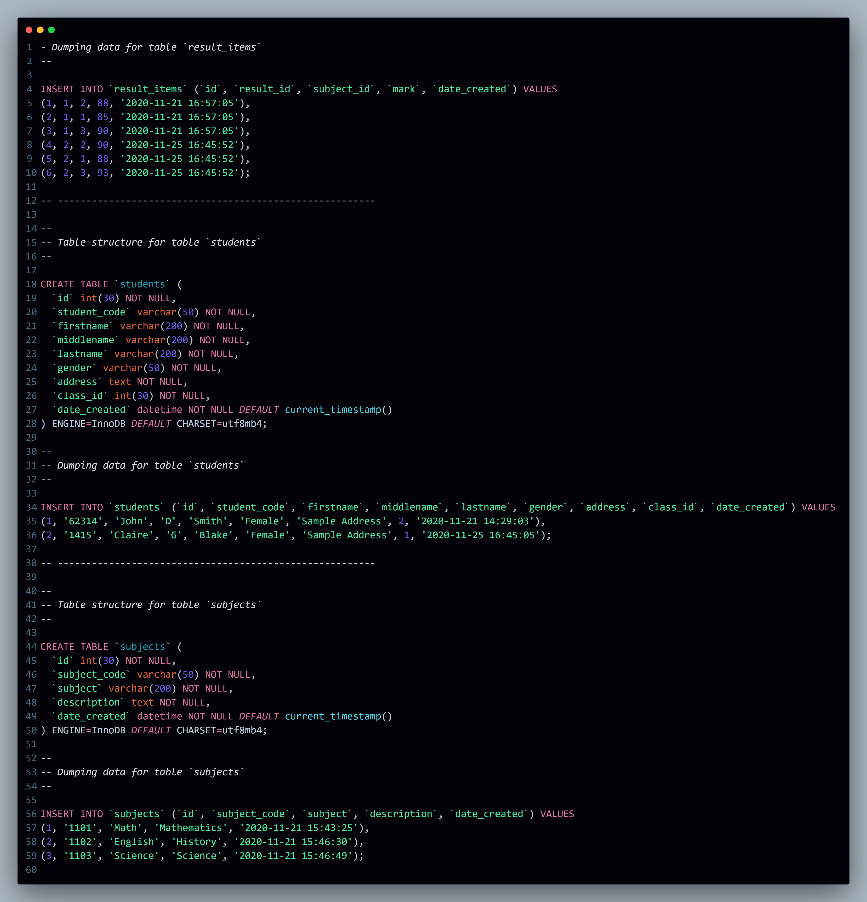

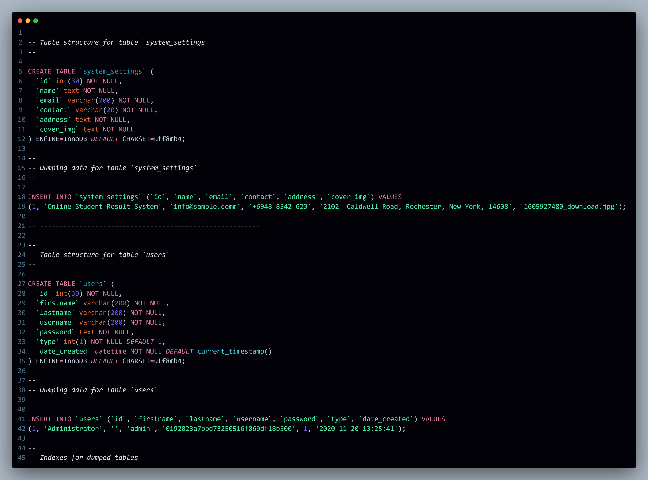

**TESTING AND DEBUGGING /RESULTS**

## Testing and Debugging/Results

### Testing Methodologies

* **Unit Testing**: Test individual components for correctness.
* **Integration Testing**: Ensure that different modules work together seamlessly.
* **System Testing**: Test the complete system to verify that it meets requirements.
* **User Acceptance Testing (UAT)**: Validate the system with actual users to ensure it meets their needs.

### Debugging

* **Error Logging**: Implement logging to track and fix errors.
* **Code Review**: Regularly review code to identify and resolve issues.

**Result**

System underwent rigorous testing and debugging to ensure its functionality, performance, and reliability. The results of this extensive process demonstrated significant improvements in efficiency and accuracy compared to traditional manual processes.

* **Efficiency**: The automated system streamlined administrative tasks, reducing the time and effort required for managing student records and results. This allowed staff to focus on more critical tasks and improved overall productivity.
* **Accuracy**: Automated data entry and processing reduced the likelihood of errors, ensuring that student records and results were accurate and up-to-date. This enhanced the reliability of the system.
* **User Satisfaction**: User feedback indicated high satisfaction with the system's usability and functionality. Both administrators and students found the system easy to navigate and effective in meeting their needs.
* **Scalability**: The system proved to be scalable, capable of handling a growing number of students, classes, and subjects without compromising performance.
* **Accessibility**: The online platform provided easy access to information for students, parents, and administrators, enhancing transparency and communication.

## OUTPUT

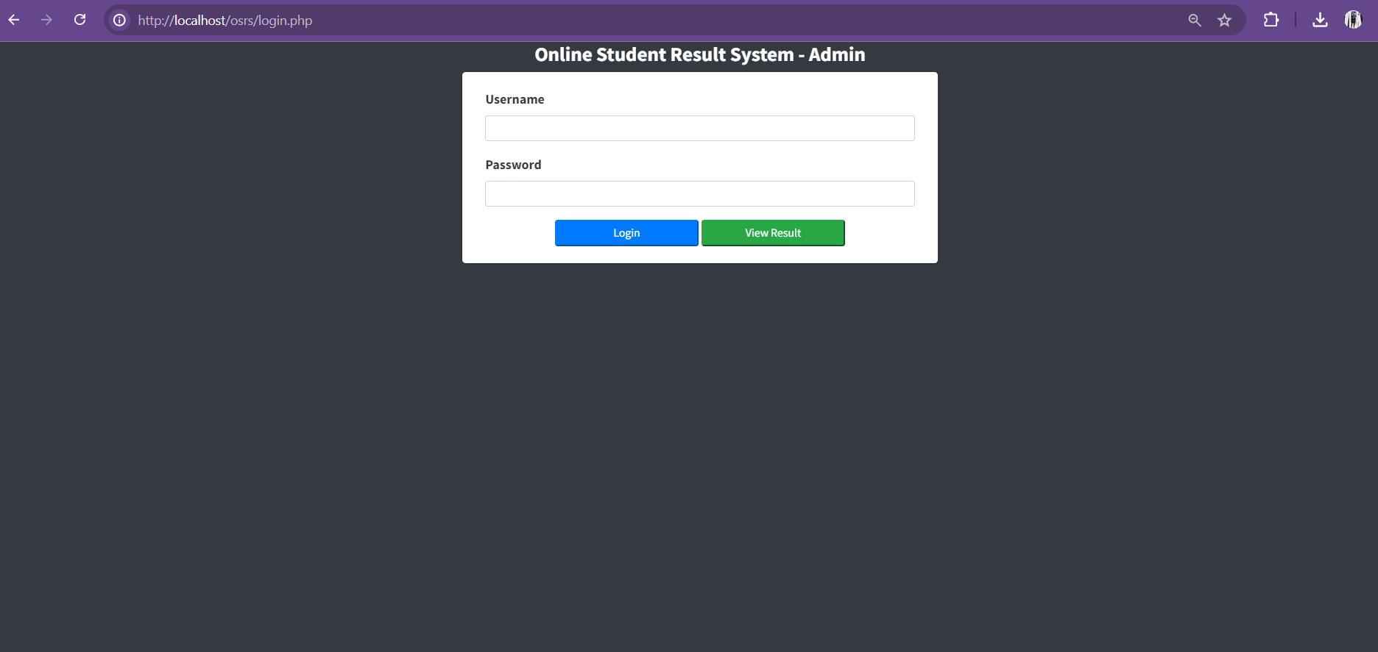

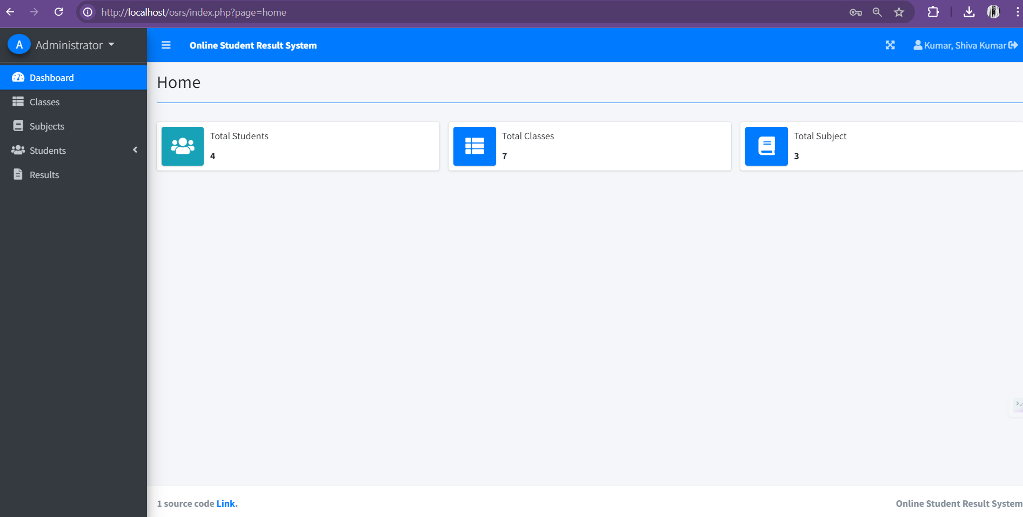

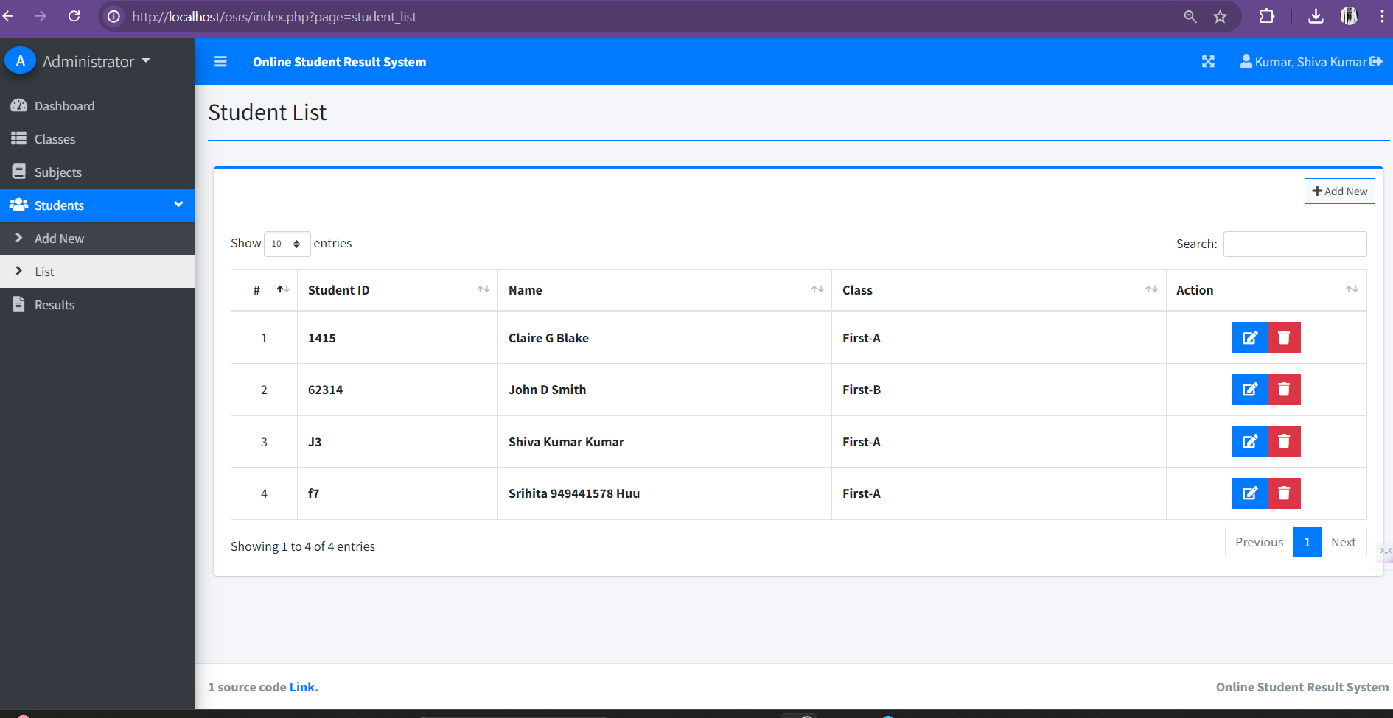

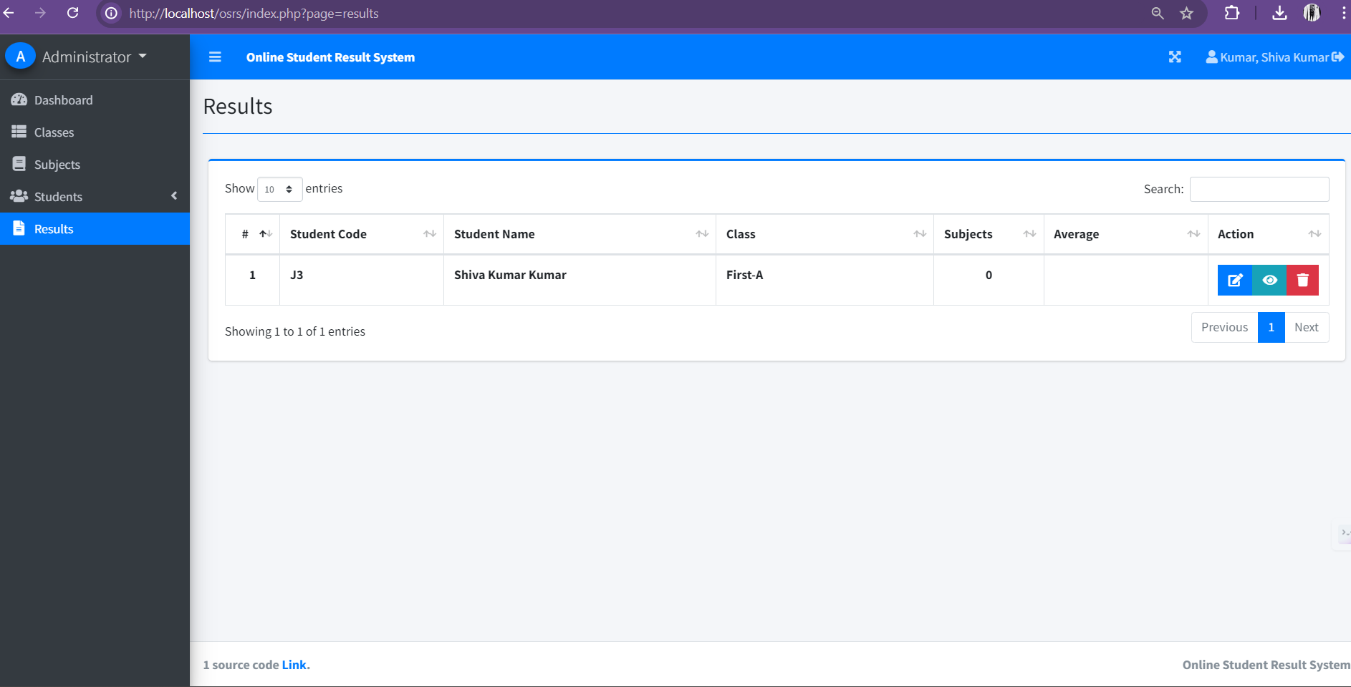

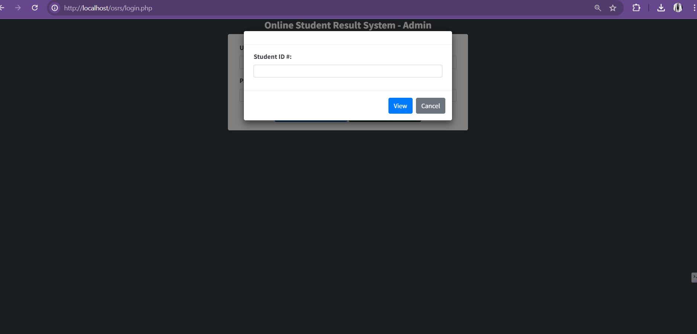

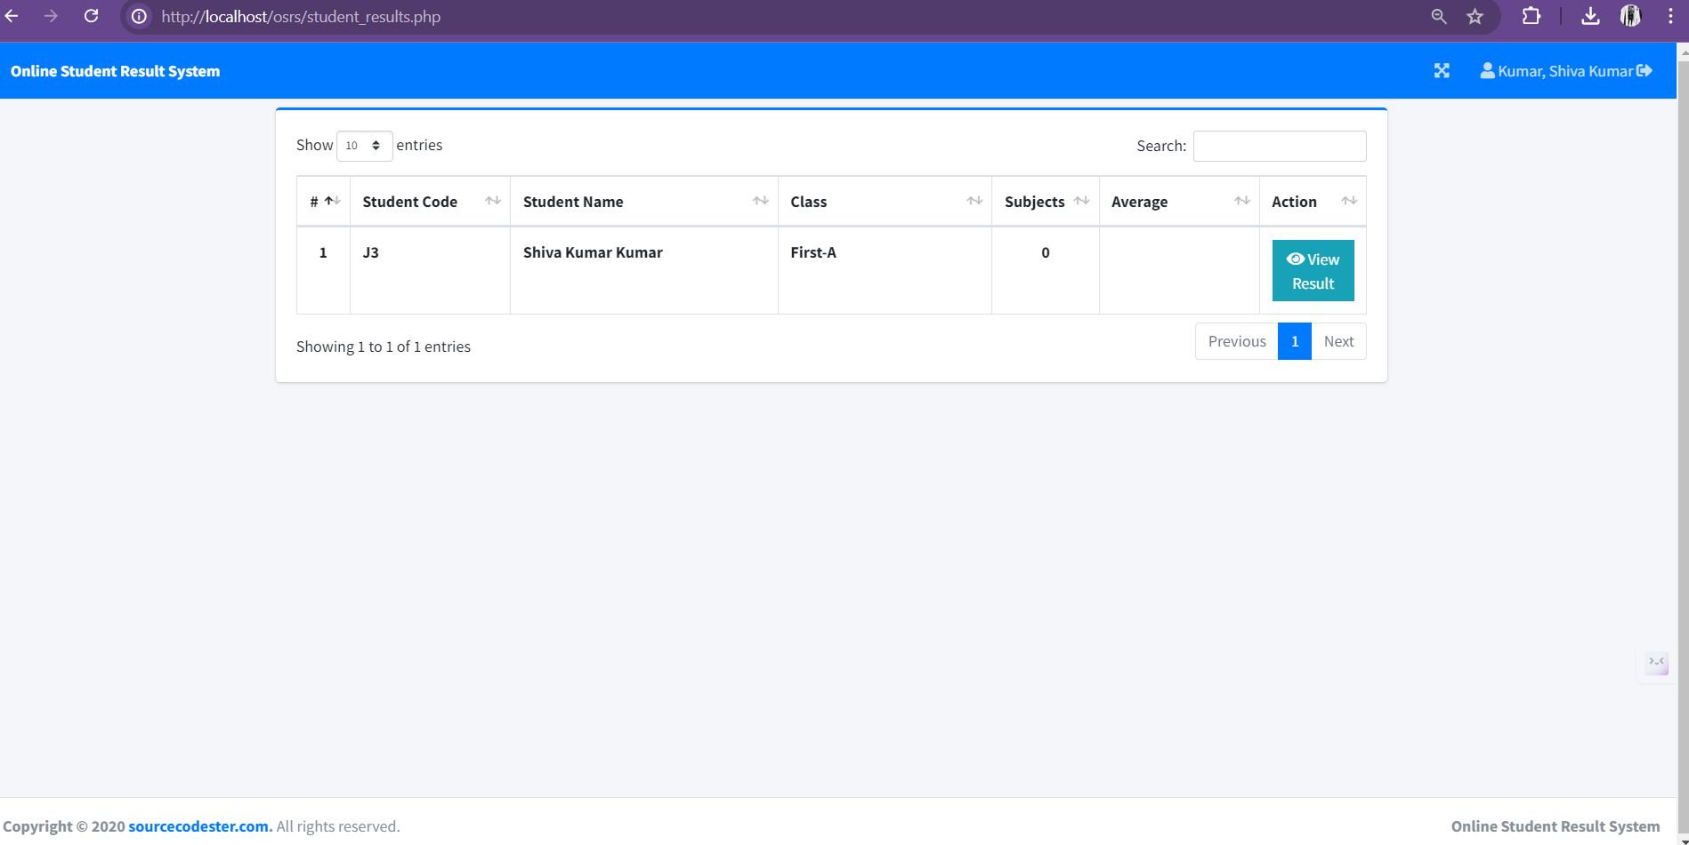

**CONCLUSION**

The implementation of the Online Student Result System marks a significant advancement in the management of academic records and results for educational institutions. The system has demonstrated its capability to streamline administrative processes, reduce errors, and enhance overall efficiency. Throughout the development and implementation phases, the system was meticulously designed, tested, and refined to ensure it meets the specific needs of both administrators and students.

### Summary of Benefits

**Efficiency and Automation** The Online Student Result System automates many of the labor-intensive tasks associated with managing student records and results. This automation reduces the administrative burden on staff, allowing them to focus on more strategic and impactful tasks. By eliminating manual data entry and processing, the system significantly speeds up the generation and publication of results, ensuring timely access to information.

**Accuracy and Reliability** Automated data processing reduces the likelihood of human error, leading to more accurate and reliable academic records. The system's robust data validation mechanisms ensure that all information is consistent and correct, providing a trustworthy source of student performance data.

**REFERENCES**

### • Primary Sources

#### Laudon, K. C., & Laudon, J. P. (2019). Management Information Systems: Managing the Digital Firm. Pearson.

This book provides a comprehensive overview of management information systems, covering their role in business and strategies for managing digital firms effectively. It was crucial for understanding system integration and data management for the Online Student Result System.

#### Date, C. J. (2004). An Introduction to Database Systems. Addison-Wesley.

A foundational text on database design and management, this book offers insights into data modeling, normalization, and query optimization, which were essential for creating the database structure of the Online Student Result System.

#### Sommerville, I. (2015). Software Engineering. Pearson.

This book covers software development methodologies and best practices, guiding the entire development lifecycle of the Online Student Result System to ensure a robust and maintainable software solution.

**APPENDICES**

### Appendix A: User Interface Screenshots

* **Admin Dashboard**
* **Class Management Page**
* **Subject Management Page**
* **Student Management Page**
* **Result Management Page**
* **Student Result View**

### Appendix B: Database Schema Diagrams

* **ER Diagram**: Showing relationships between classes, subjects, students, and results.
* **Table Structures**: Detailed schema of each table.

### Appendix C: Test Cases

* **Unit Test Cases**: Test cases for individual components.
* **Integration Test Cases**: Test cases for module interactions.
* **System Test Cases**: Comprehensive test cases for the entire system.